**LANDVIZ Trouble Shooting – Report**

**16.02.2017**

**Johannes Liem**

**Problem: Re-building the LANDVIZ PreProcTool after amending code for *float* raster cell sizes**

**Changes in LANDVIZ Code:**

File: l2utils\collector.py

Line 231 and 235: ***int*** was changed to ***float***

**Changes based on new GDAL version (gdal.InvGeoTransform):**

File: tilertools\tiler_backend.py

Around Line 523: Changed the commented two lines to the following lines

#ok, dst_igeotr = gdal.InvGeoTransform(dst_geotr)

#assert ok

dst_igeotr = gdal.InvGeoTransform(dst_geotr)

assert dst_igeotr

Around Line 548: Changed the commented two lines to the following lines

#ok, dst_igeotr = gdal.InvGeoTransform(dst_geotr)

#assert ok

dst_igeotr = gdal.InvGeoTransform(dst_geotr)

assert dst_igeotr

**Changes based on new NumPy version (numpy.add):**

File: l2utils\mapworker.py

Line 141: added parameter casting=”unsafe”

data = np.add(data, 2147483648, dtype='uint32', casting="unsafe")

**Changes based on what ever reasons:**

Localizing the landviz install folder from within the main.py script, didn’t work anymore as expected. A helper module (module_locator.py) was added, imported in main.py and used when figuring out the application path:

File: main.py

Around Line 60:

appPath = module_locator.module_path()

**Development Environment**

LANDVIZ is using **Python 2.7 32 bit** version (latest version 2.7.13).

1. Download and install: <https://www.python.org/ftp/python/2.7.13/python-2.7.13.msi>
2. Set Windows Environment Variables/Paths (HowTo: <http://www.computerhope.com/issues/ch000549.htm>)
   1. To the **Path** Variable add C:\Python27; C:\Python27\Scripts and C:\Python27\Lib
   2. This is important, in case other Python Installations are installed

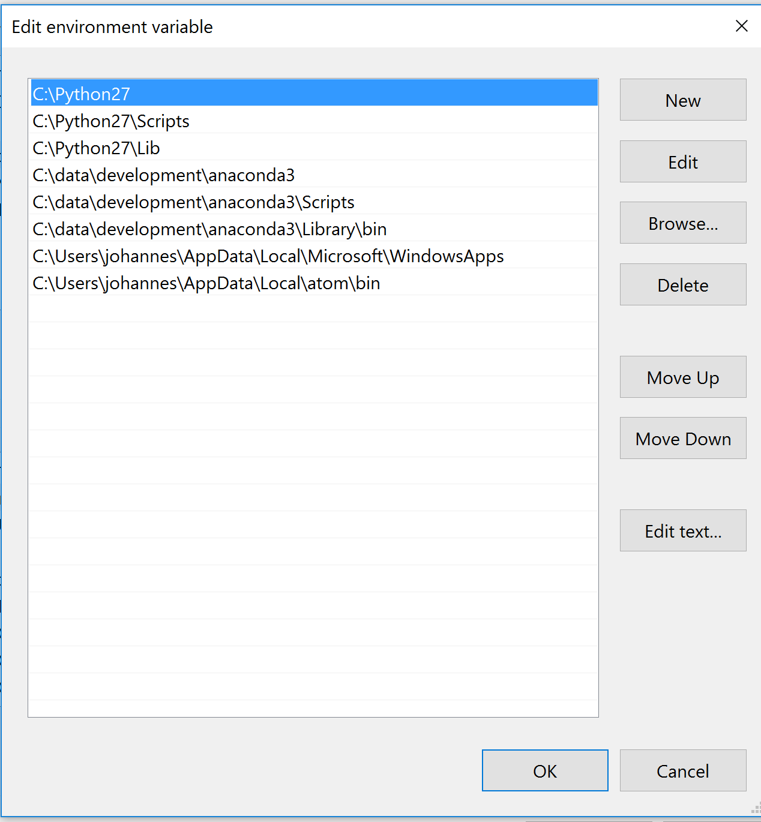

1. Test if correctly installed:
   1. Start Command Prompt (cmd.exe) (Run As Administrator)
   2. Do the following to check that the correct python and pip version is used

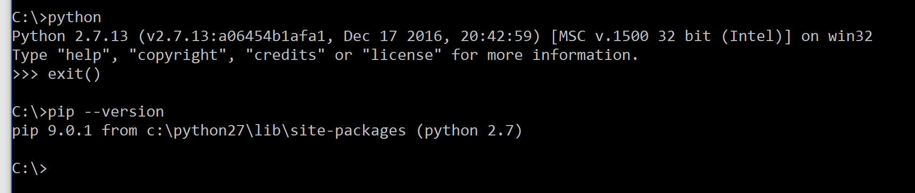

1. **Download** required python wheel packages (for **Python 2.7 32bit**) from <http://www.lfd.uci.edu/~gohlke/pythonlibs>
   1. **GDAL**‑2.1.3‑cp27‑cp27m‑win32.whl
   2. **numpy**‑1.12.0+mkl‑cp27‑cp27m‑win32.whl
   3. **scipy**‑0.18.1‑cp27‑cp27m‑win32.whl
   4. **lxml**-3.7.2-cp27-cp27m-win32.whl
   5. **PyYAML**‑3.12‑cp27‑cp27m‑win32.whl
   6. **regex**‑2017.2.8‑cp27‑cp27m‑win32.whl
   7. **Pillow**-4.0.0-cp27-cp27m-win32.whl
   8. **pywin32**‑220.1‑cp27‑cp27m‑win32.whl
   9. **pefile**-2016.3.28-py2.py3-none-any.whl
   10. **PyInstaller**-3.2.1-py2.py3-none-any.whl
   11. **CherryPy**-10.1.0-py2.py3-none-any.whl (only if the local server exe will be changed)
2. **Install** required python wheel packages:
   1. Navigate to the folder you stored all the packages in
   2. Use: pip install packagename.whl to install
   3. Please install them in the order as listed above



* 1. Important: For PyWin32 do as following:
     1. To install pywin32 system files, run `python.exe Scripts\pywin32_postinstall.py -install` from an elevated command prompt.
     2. 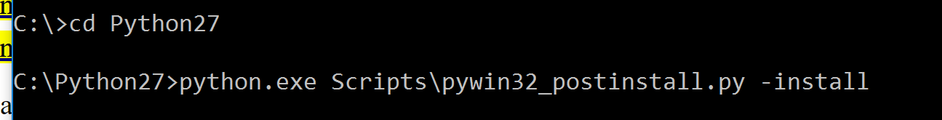

**Test the code:**

Before you build the PreProcTool, test the code. Setup a test project. In PreProcTool\test open test_source_main_py.bat with a text editor and change the input xml and output folder paths (not the one to the main.py).

If there are no problems you can build the PreProcTool.

**Building the PreProcTool:**

* In PreProcTool\build run build_preproctool.bat
* Make sure that **PreProcTool.spec** is in the same folder (Do not delete this file)!
* Before rebuild you may delte the folders **build** and **dist** (within PreProcTool\build) (Ohterwise you have to say Yes when asked to delete the folders; and maybe some old code will be used).

**Building the MSI Installer using advanced installer (free trial version)**

As described in the Documentation (just changed the gdal-data path to: [APPDIR]osgeo\data\gdal)

Find Installer in: C:\...\LANDVIZ-master\PreProcTool\build\installer\LandisPreProcToolInstaller-SetupFiles

The **BAU_short_clip** example:

Note: For both century outputs (ag-npp and nee) the file/folder path information in the coresonding Metadata.xml was wrong.